-Tools:

Android studio

Fire base

Retrofit

Google Colab

TensorflowLIte

-Splash activity

First we start with splash activity the purpose of it is to check if the phone connected to the internet or not with beautiful design and logo this the entrance of our app.

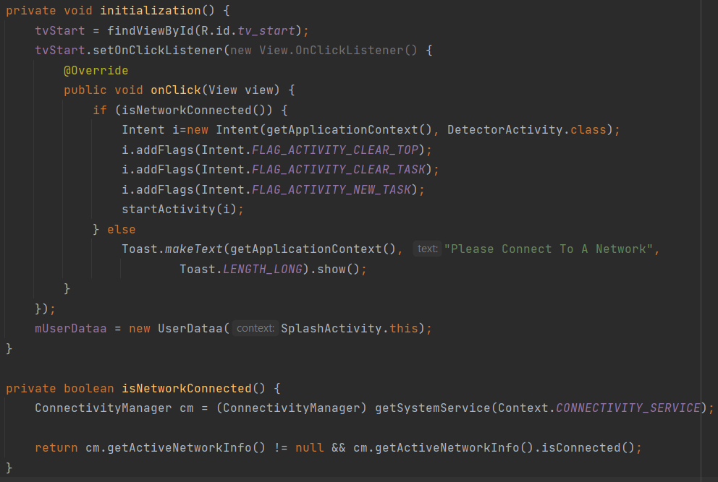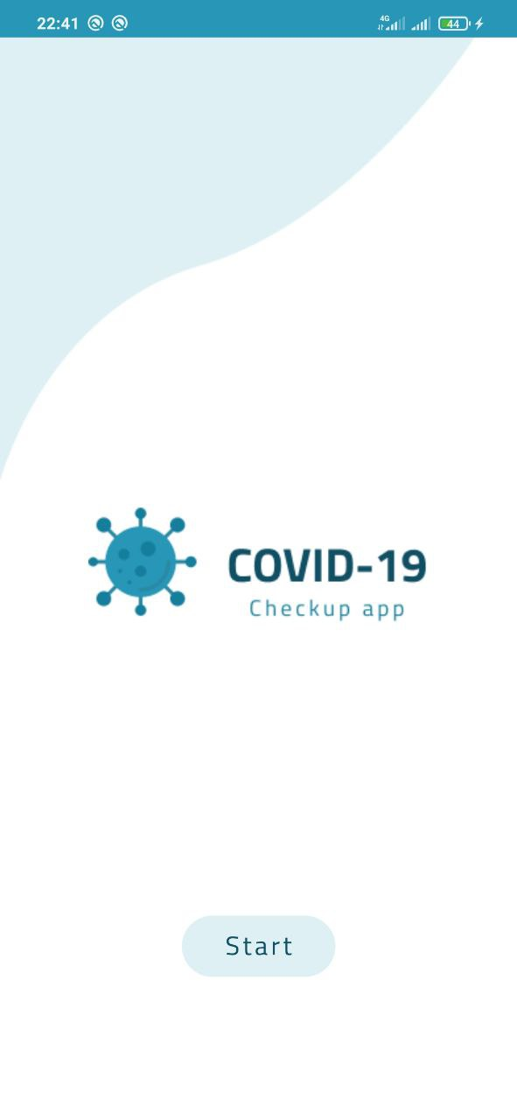It has only one button called start.

Figure 1.2

Figure 2.1

The main purpose of this screen is to check the phone is connected to a network or not so:

1. We intiate the views
2. Check the network by using isNetworkConnected function
3. If connected navigate to cam activity
4. If not print toast

-Camera Activity

This Activity uses to check if he/her is wearing facemack or not, if not this app not opened to Login Activity .

Firstly it asking the user to give the permission to access phone camera , after this open on the front camera and detect if are you wearing the mask if not your face rounded by red rectangle and the top of this rectangle has the percentage of this face of not wearing the mask.

If the user wearing the mask , his face will rounded with green rectangle and the top of this rectangle has the percentage of this face of wearing the mask.

If the face of the user has the blue rectangle that mean it in confusion area and you should clear the lens of camera to see you clearly and wear the mask in right way.

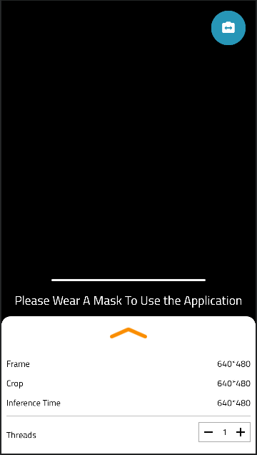

Figure 1.3

This app does’t used one time to check it used several times to ensure that the user wearing the mask

And if the wear out the mask in this operation will be stop and the line tells the user if he/her is near to complete the check.

You can look at Figure 1.3 to see what we talk about ?

if the front camera have issue or noisy by click on the switch button to access the back camera if he user want.

In figure 1.4 we can see the implementation of the switch button .

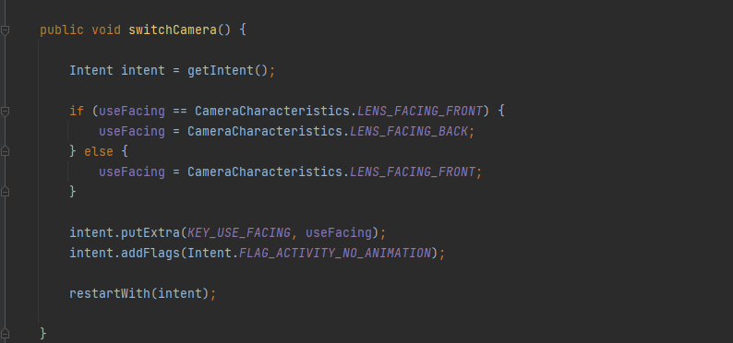

Figure 1.4

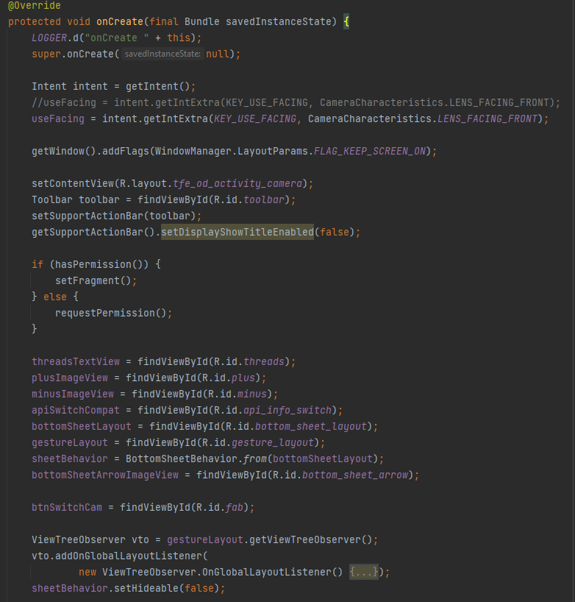we will get snapshot of code to

Figure 1.5

explain the idea not all impleme-  
-ntation .

now we will dive in all onCreate   
function in our code (Figure 1.5).

In first we are asking to check   
if our application the the   
permission to access the camera   
or not

After this go to get the IDs of   
XML file to get access our   
Design.

After getting IDs of XML,  
we used JAVA to customize   
our Design to get access hardware

Camera to layout on XML

After reserving IDs to variable in JAVA class used function onImageAvailable to make preprocess operations on image before display it on layout in XML file.

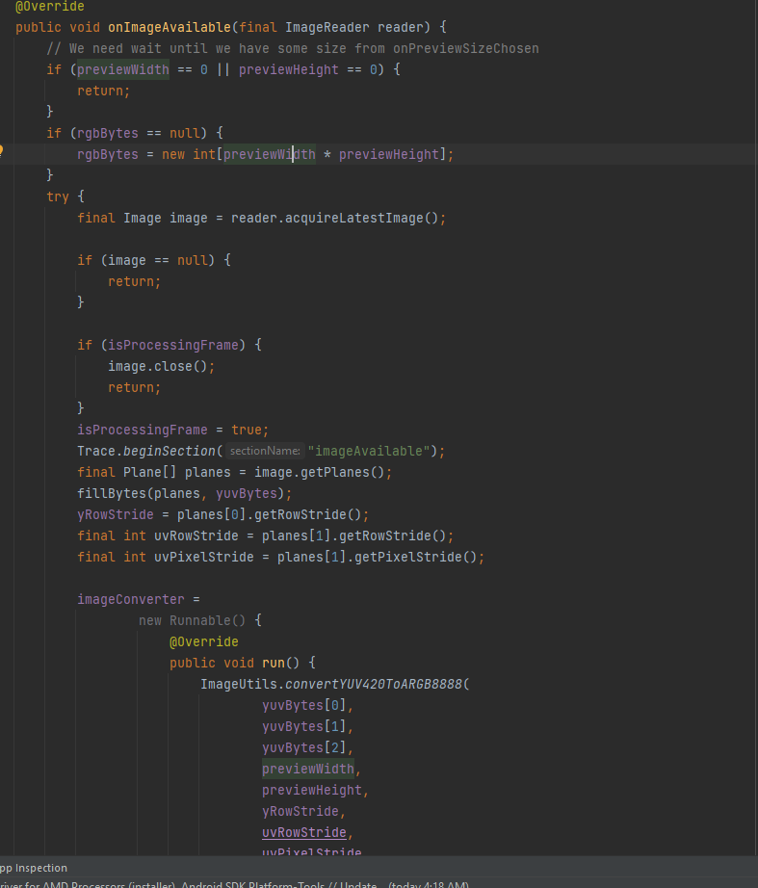in Figure 1.6 the onImageAvailable  
used to get the image from sensor  
camera and saved in variable on  
memory and invoke the function   
processImage.

In this function , we to make some   
operation on image and it is invoked   
from DetectorActivity Class in java

Figure 1.6

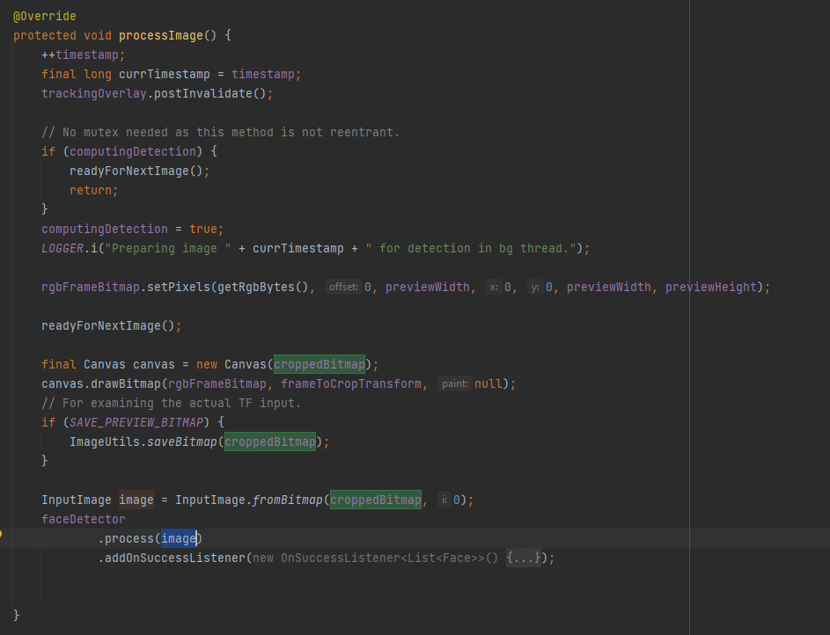

Used to Data type of convas  
to get drow in image and

Transfer it to bitmap after this   
transformation this image go to   
Class faceDetector to check this is  
 face or not and return the image .

Figure 1.6 explain what are we taking about?

Figure 1.7

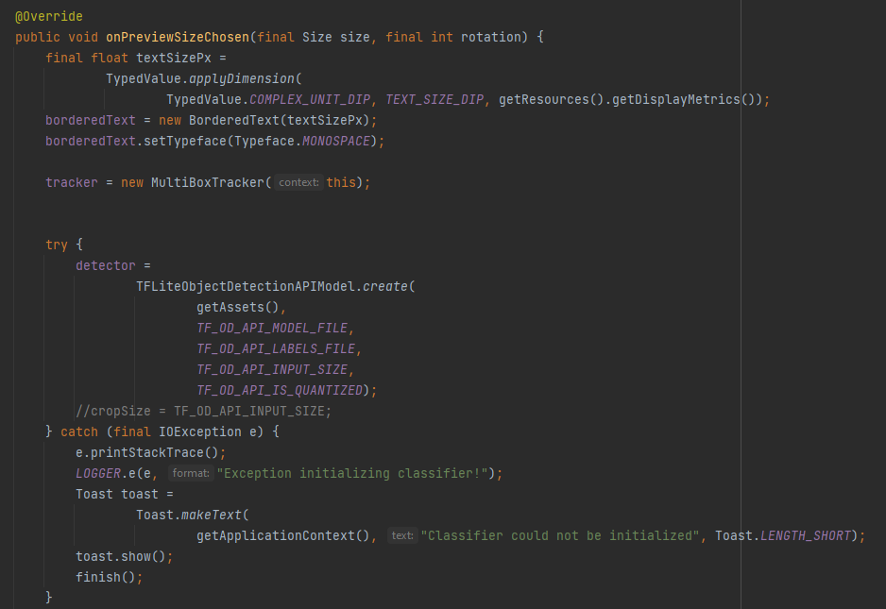

in figure 1.8 we implement onPreviewSizeChosen  
Function to initiate tracker to track faces which   
captured by class detector.

And initiate model to get be implemented on faces   
to check he/she is wearing mask or not   
 we initiate in try catch function to ensure the model   
is initiated and ready to be used without errors .

Figure 1.8

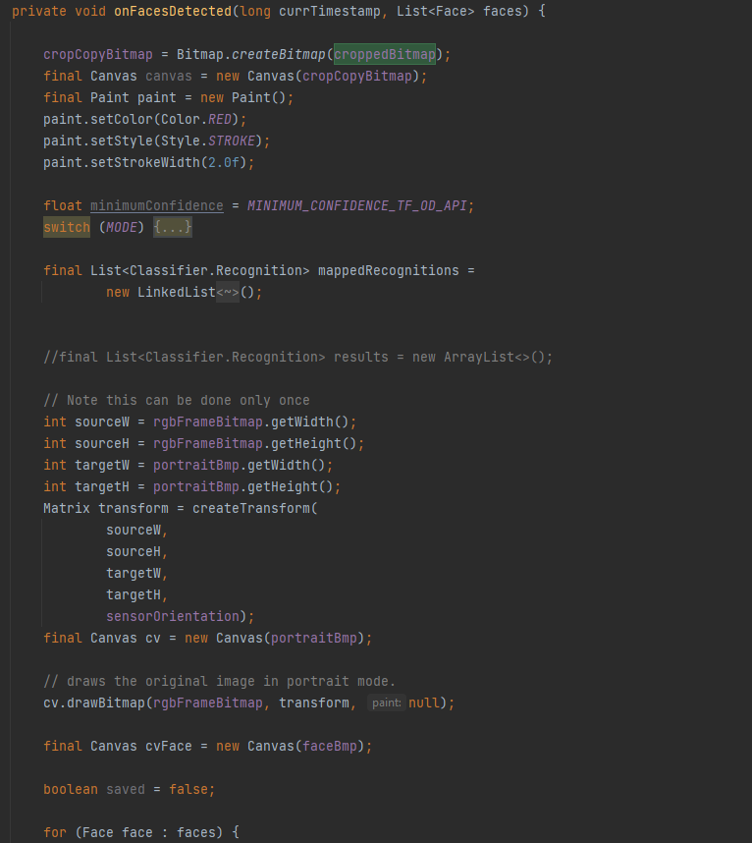  
  
in figure 1.9 this functions invoked by list of faces   
needed to be check who wear mask and who don’t  
 wear mask.

Figure 1.9

We initiate variables and same API   
to get Access Camera , and we initiate the list of class   
Classifier.

After this we loop in list of faces to detect   
people with mask and without mask   
and initiate to get draw on source image   
and initiate the matrix to restore the orientation  
transform it by get source , target and the angle   
that which has orientation to remove this issues.

We transform to get the default orientation

And apply the model on it to get the best result.

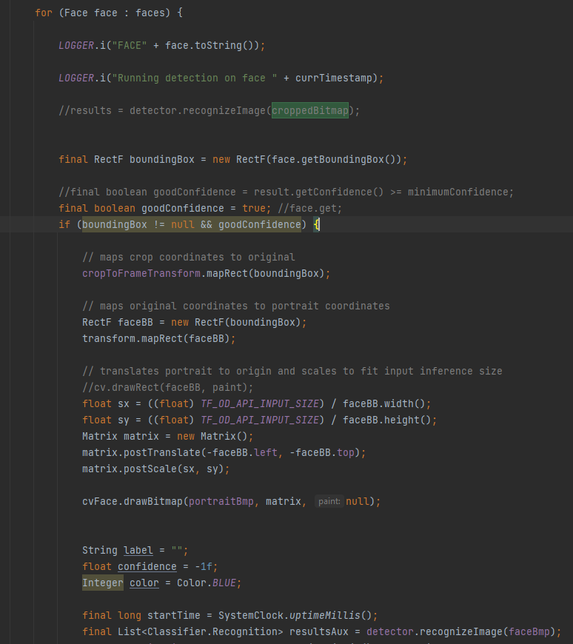

Figure 1.9.1

As we see in figure 1.9.1 we loop on list of   
faces , and apply the model on every face   
and get the result from it .  
now we want to check the result of   
this face to inform this face wearing the mask   
, not or not sure .  
  
  
after this we implement same important   
operations to get clear and real result   
and save the confidence of every face   
to be checked in figure 1.9.2.

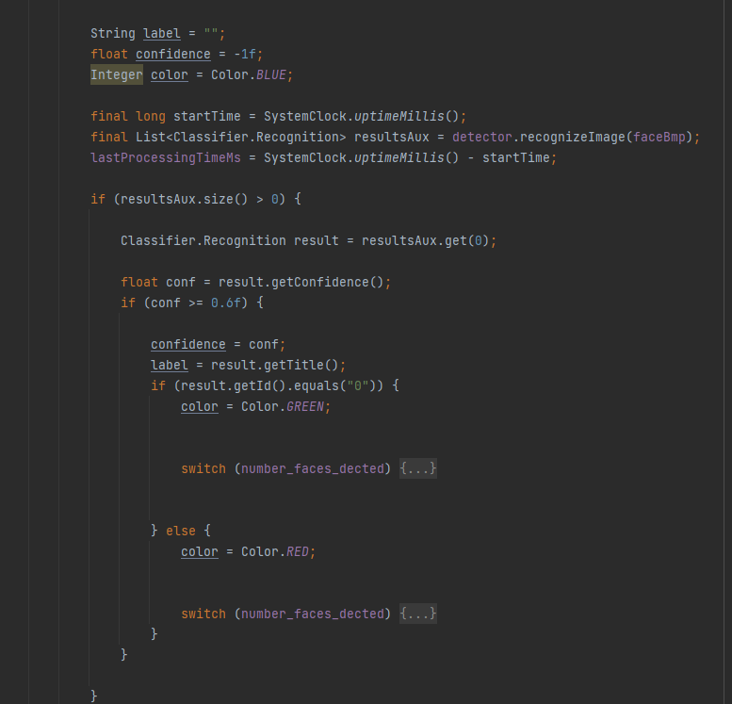we not consider the faces with confidence   
less than 60%, and we focus in greater than   
it to get the best real result .   
 now we check the matrix of [0,1]

Figure 1.9.2

if (0) this wear the mask   
if (1) this not wear the mask

wearing the mask round it by green   
rectangle

not wearing the mask round it by red   
rectangle  
not sure not wearing the mask round it by   
blue rectangle

if successful in wearing mask constrain  
, the app will go to login activity  
or home if he/she have Sign in earlier

Authentication:

-log in activity

We use firebase authentication in our app for manage users and registration log in activity has only two edit texts for email and password, log in button and register button for new users after check if users wear masks or not the app automatic navigate to log in. user has two options:

1. Already a user so he will just log in with his email and password
2. 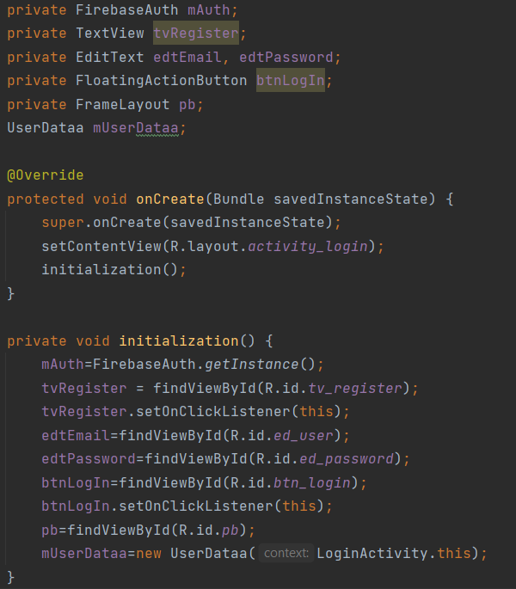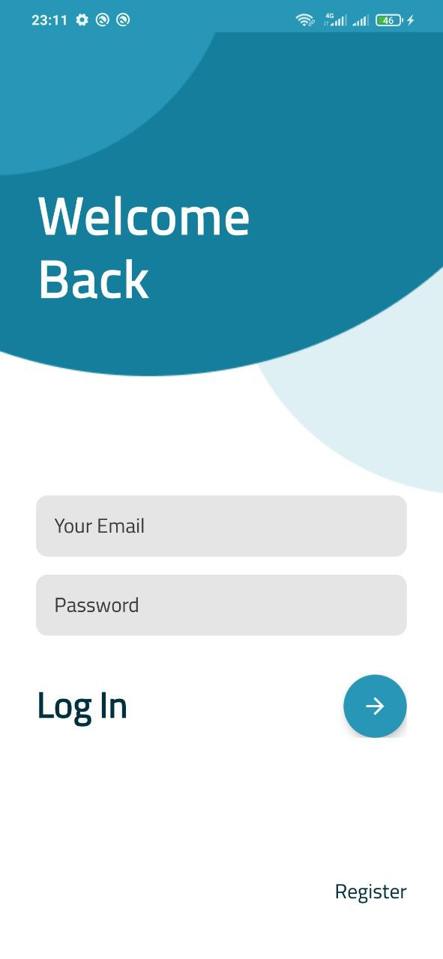New user so he will register and enter his data.

The action occurred when the floating button is pressed so we write the code in the button.

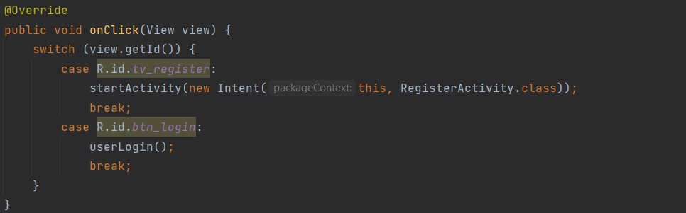After initializing views in log in activity we can access, control and handle it like getting, saving data and validate it and so on…

This is on click method we handle all click actins within log in activity on it we have the most important function in it which is userLogin(); this function doing all process to log in the user.

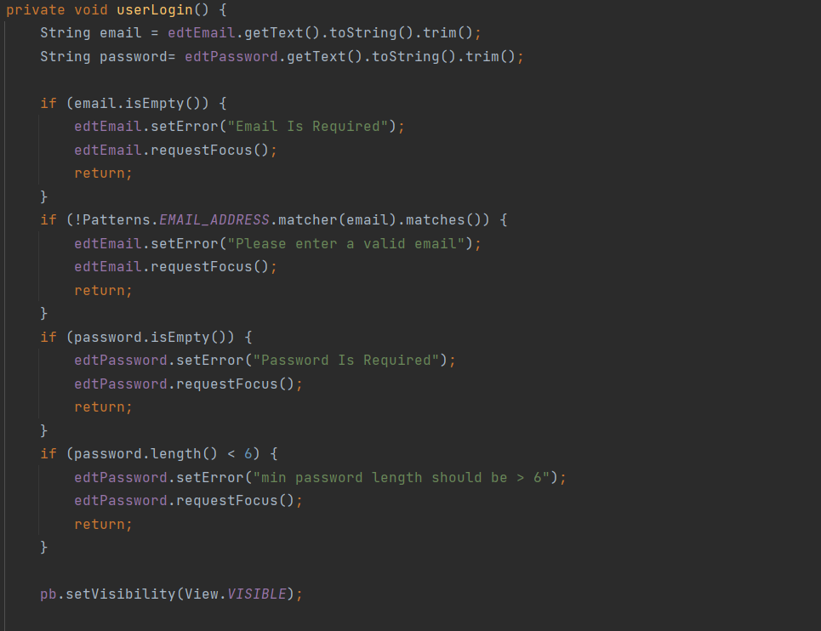

First we get the email and password from EditTexts by using getText() function, convert them into string and finally delete any spaces after or before the text by using trim() function.

Second we have some checks on the email and password that user enters it:

* is the email empty?
* is the user entre invalid email?
* Is the password empty?
* Is the length of the password less than 6 characters?

After all that checks we have an valid email, password next and final check is the email registerd , user entre the correct password and firebase will check that.

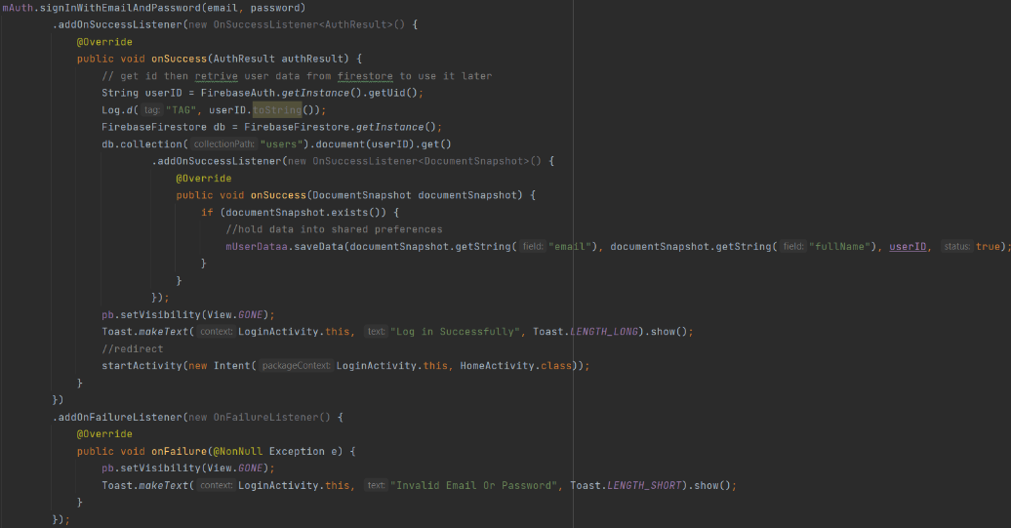we use firebase signInWithEmailAndPassword function and pass email, password to it, then it connects with firebase authentication to check the data, if the user exists and the password is correct we can log in but first we need to store some info about user so we access fire store and get some data that can be used later and store it locally in shared preferences.

* First check email and password if invalid print toast with the error
* If valid
  1. Get user id
  2. Access fire store data
  3. Get the data of the user and store it in shared preferences.
  4. Data like email, full name and id
* If not valid we get the error code from firebase by using exception

After all that steps we log in and navigate to home screen.

If the new user need to register he will just go to register activity by pressing register button it will navigate to register screen.

Register Activity

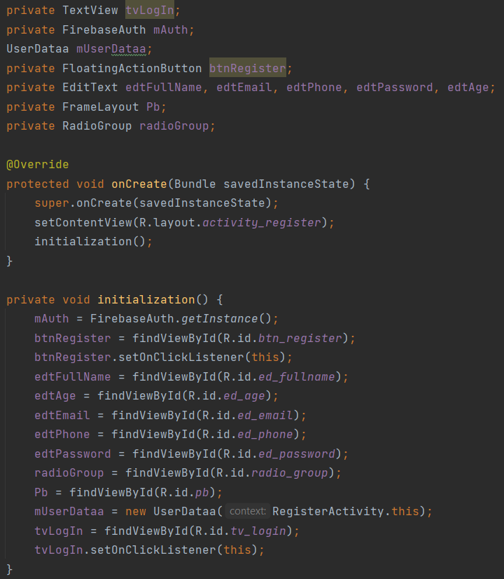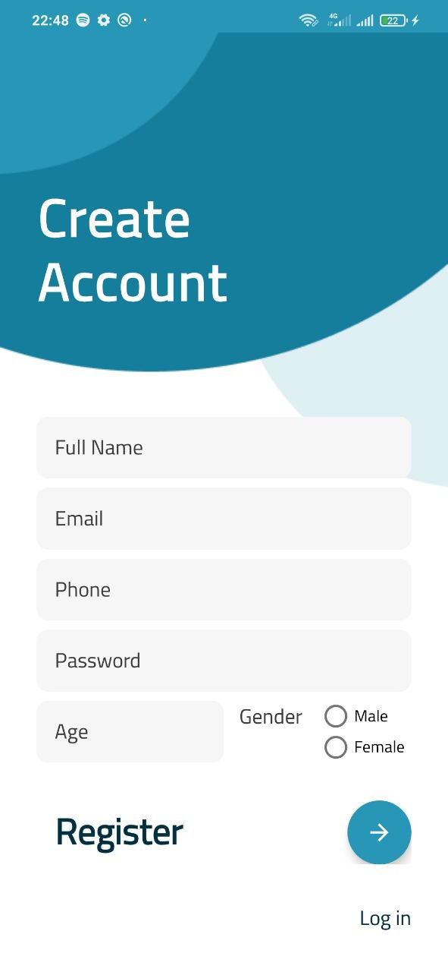The new user can easily create a new account by entre his data like his name, email, phone, password, age and finally select his gender.

The screen consists of some edit texts, floating button and log in button that navigate back to login screen.

Like the login activity we use firebase authentication and firestore to save the user data

We first start with intiate views in initialization() function and then we validate inputs like we did before.

Validation for:

1. Name if the user didn’t entre anything
2. Email if user entre invalid email
3. Phone if user entre invalid phone
4. Password if user entre short password
5. Age if user entre invalid age
6. Gender if user didn’t choose anything

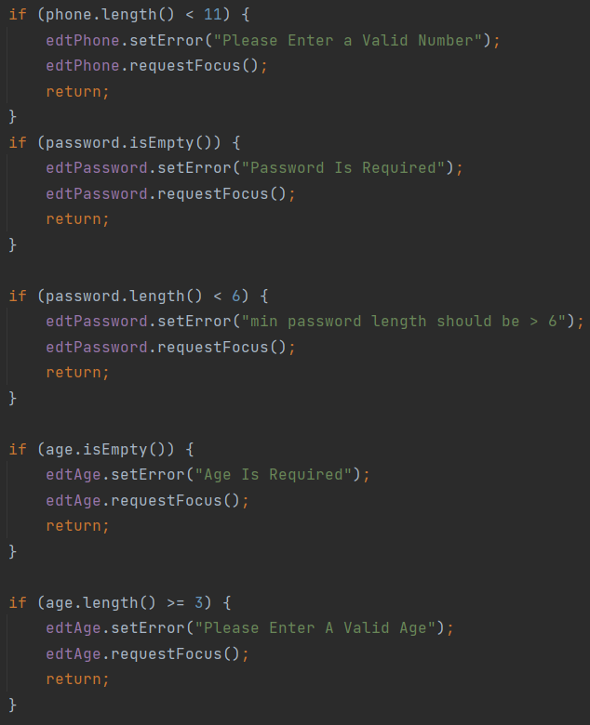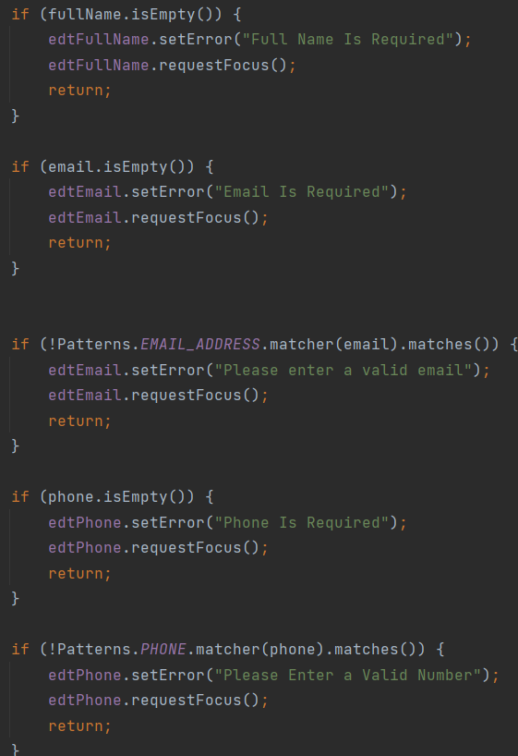

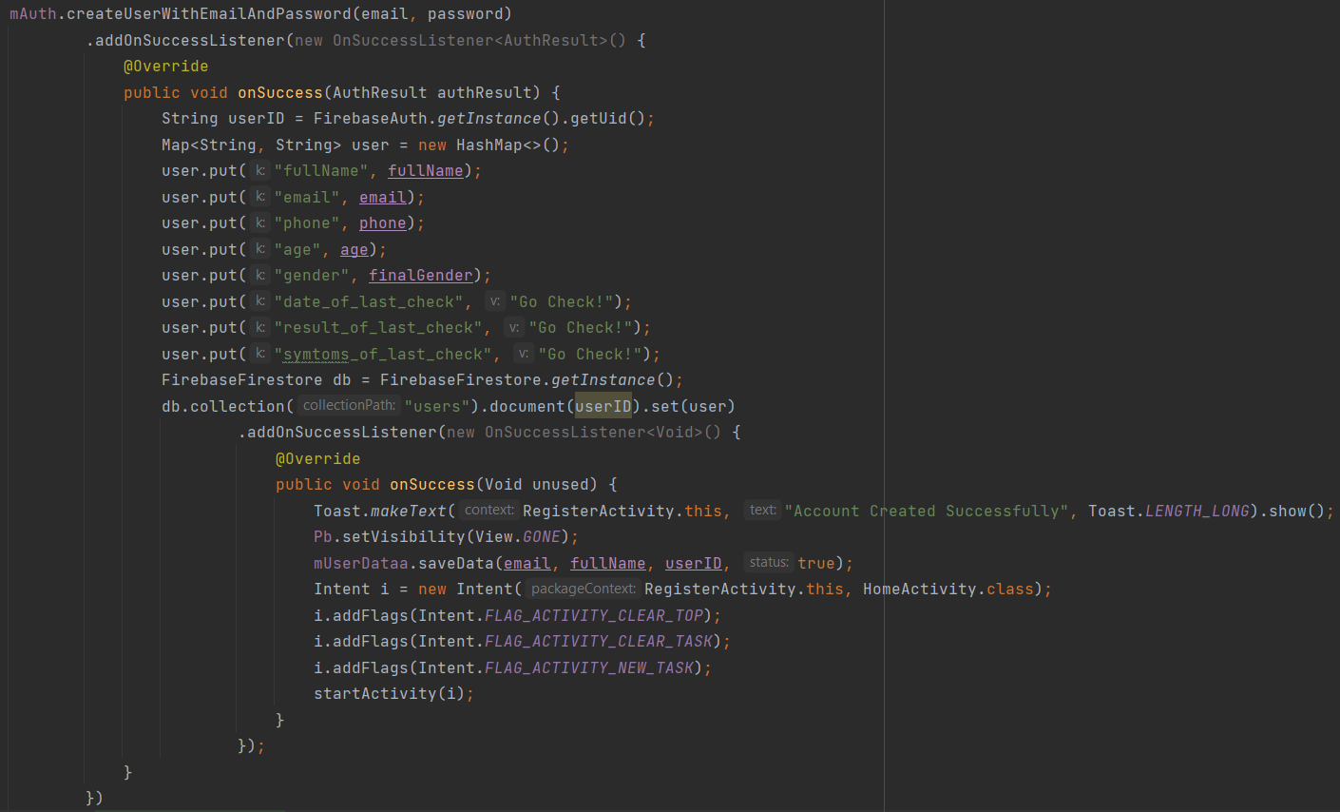After validating all data we create user using firebase createUserWithEmailAndPassword() function and it takes only the email and password so..

After creating account we save all data into firestore each user has a unique document with his id hold his data.

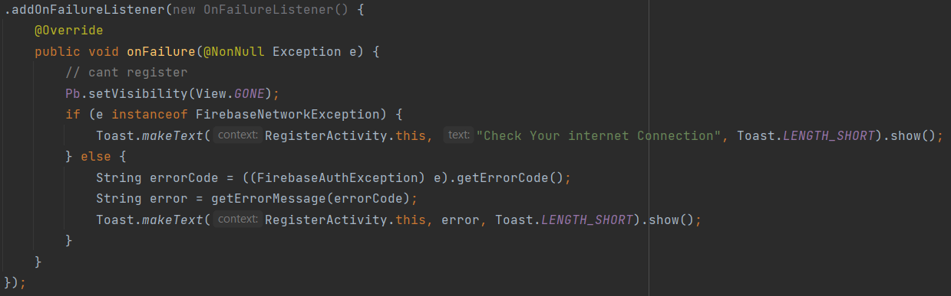If an error occurred like no connection or error in the data base we received it in onFailure method

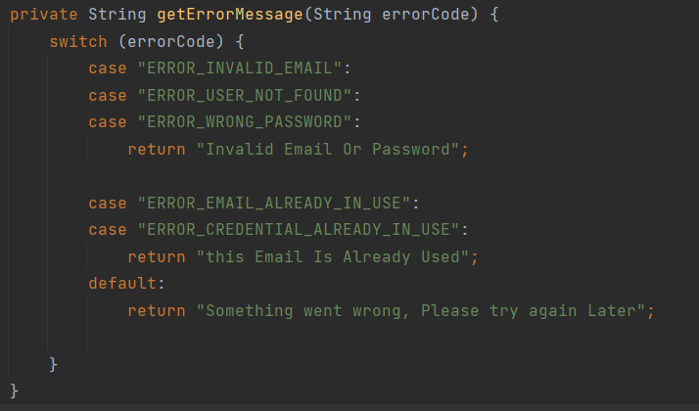We have many cases so we handle it in getErrorMessage method

After register user we navigate into Home screen that holds 3 fragments and bottom navigation view..

Home Activity

Home screen has multi options

* first we have statistics about corona cases around the world updated every day
* self-checker we can access it by clicking on let’s check-up.
* News button
* Profile Button
* 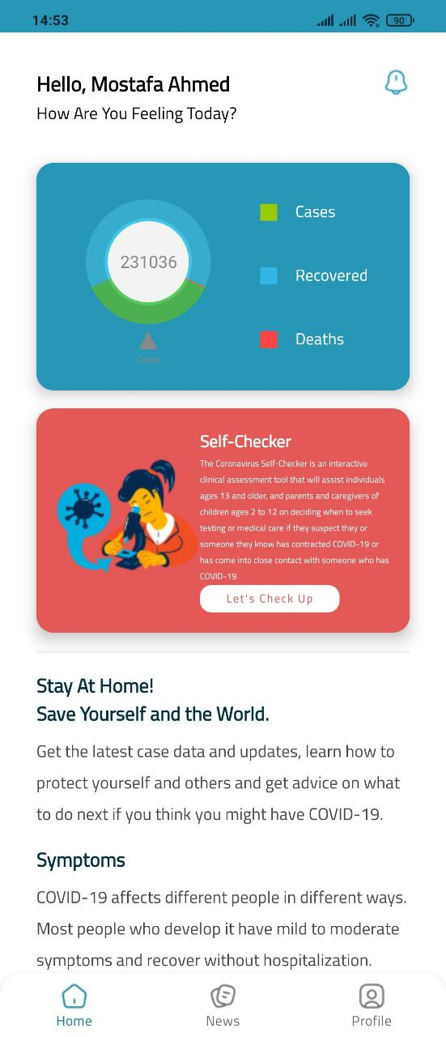Some advices

The default container in this activity is home fragment that show the statistics.

We get statistics from an public api that cover cases and updated every day. We use retrofit library to get this data. We received data as a query object and translate it into java object.

* First we have 3 classes that helps to get data from the api
  1. 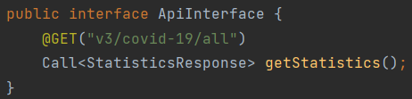An interface ApiInterface that have the get function.
  2. 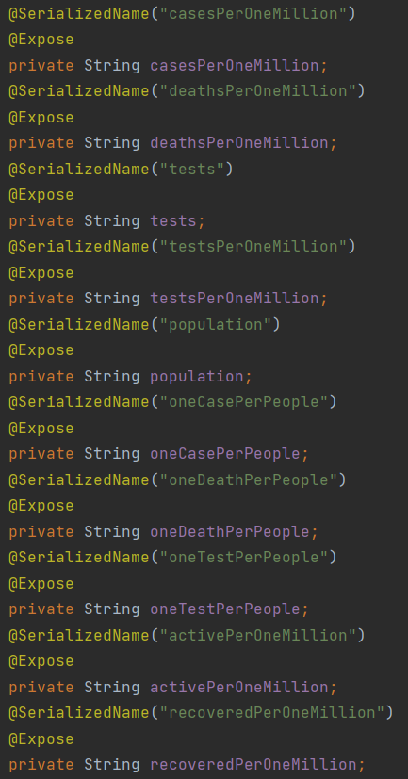StatisticsResponse class that form the data in the api. 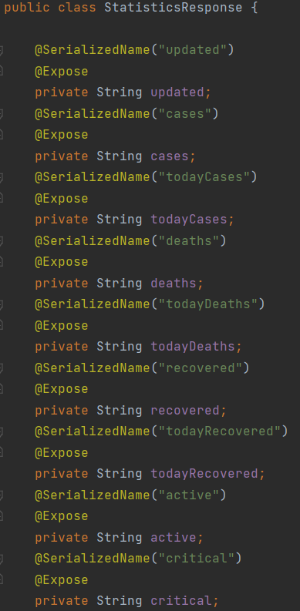
  3. WebSreviceClient class that make the call. 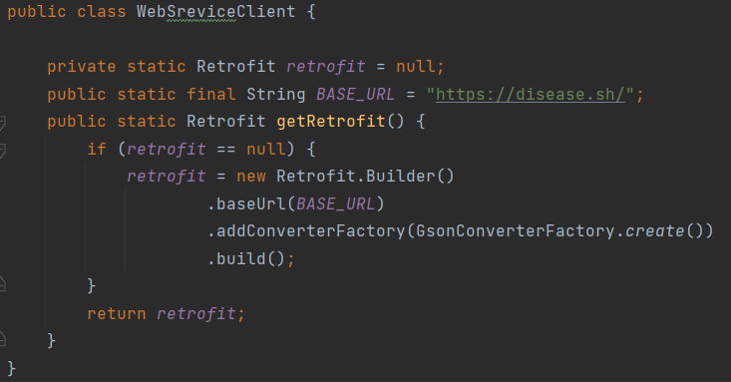

After intiating these helper classes we can easily control the data in the entire app

The home fragment holds the statistics pie chart that show 3 values

1. cases
2. recovered
3. Deaths

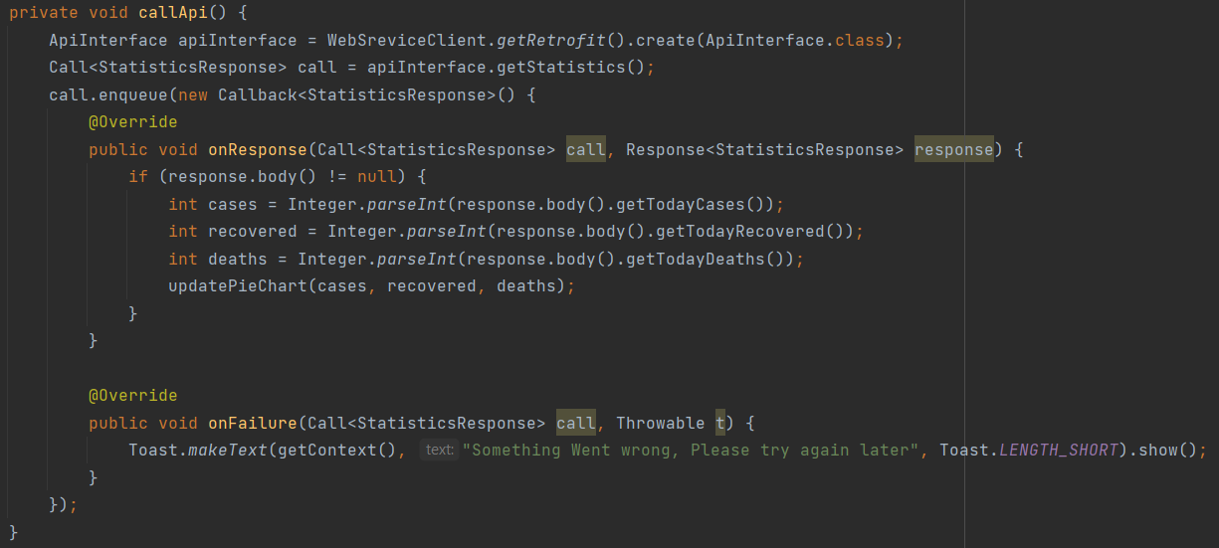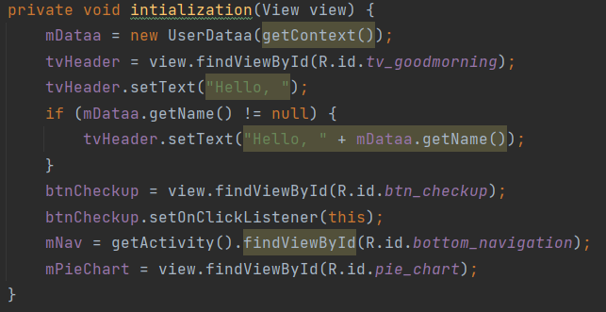After intiating views in home fragment we called a method for make the connection and retrieve the data from api.

After calling callApi() function first we make instance of the interface and we call the function that get all statistics and after get the data we parse it into integers and pass it into updatePieChart function it draw the pie chart in the screen if the connection is bad or the phone not connected a toast messege will be shown.

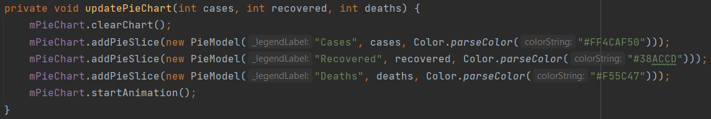

This function is only draw the results that we got from the api.

Next we have checkup button that start a few questions that determined if the user have corona or not..

Questions Screen

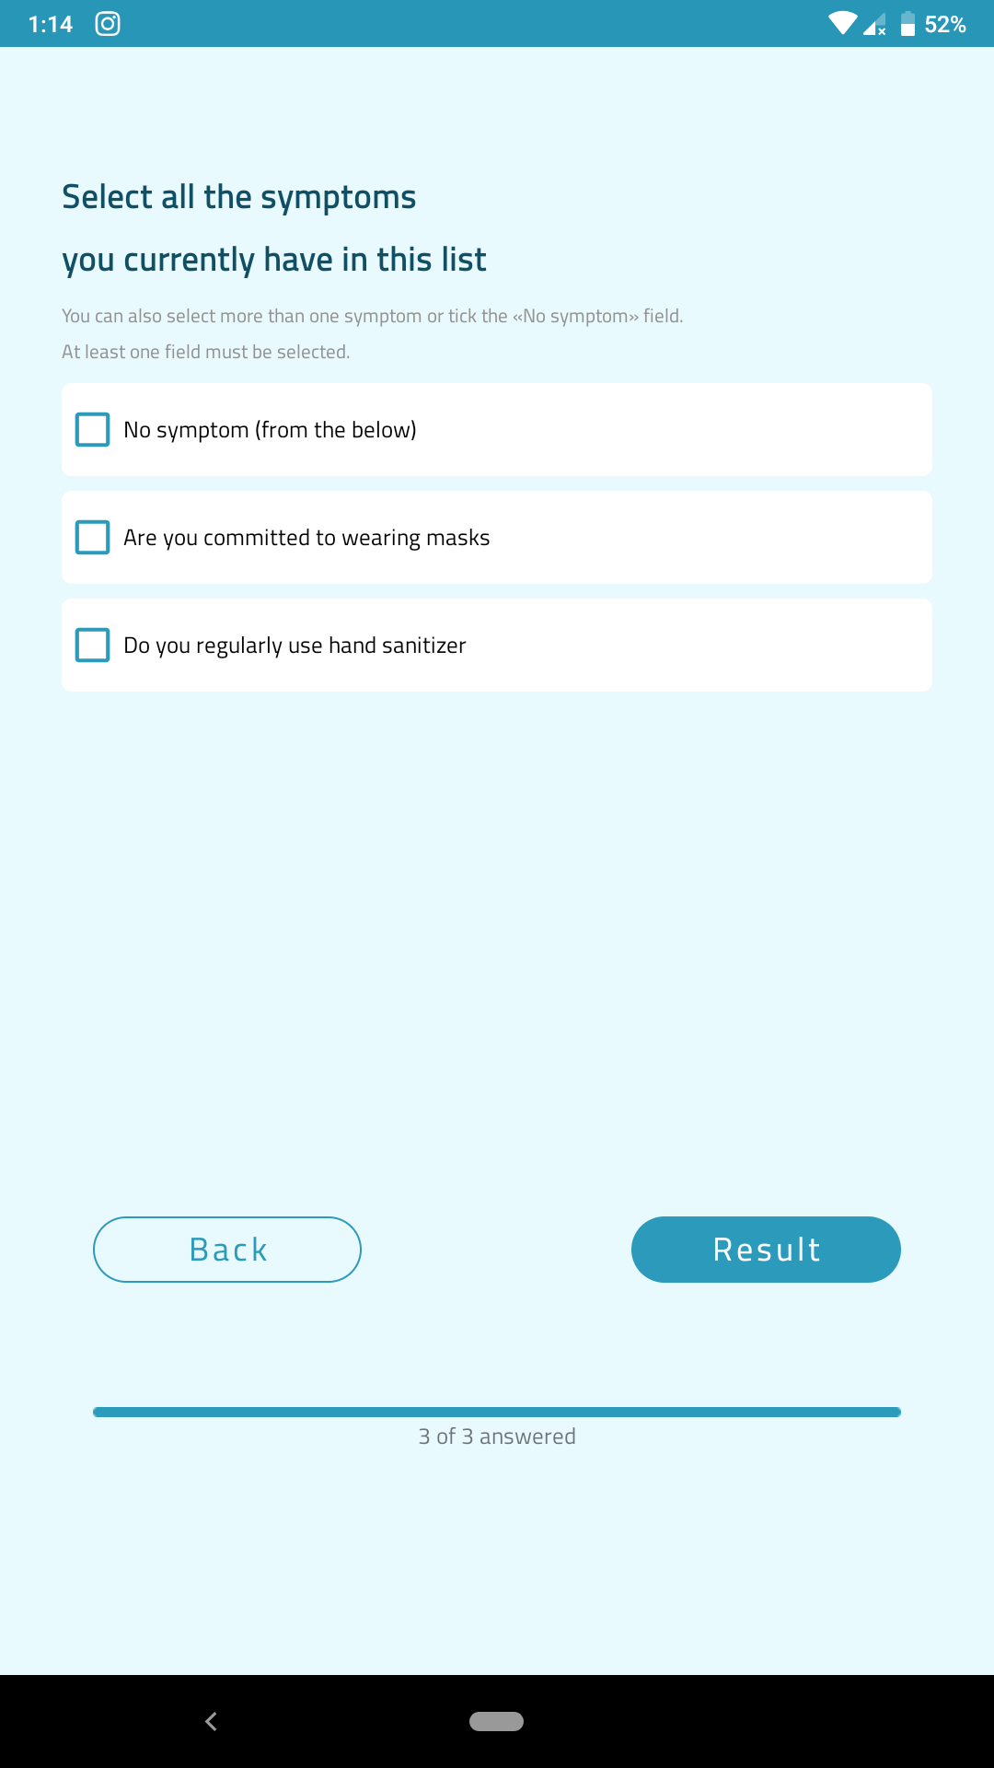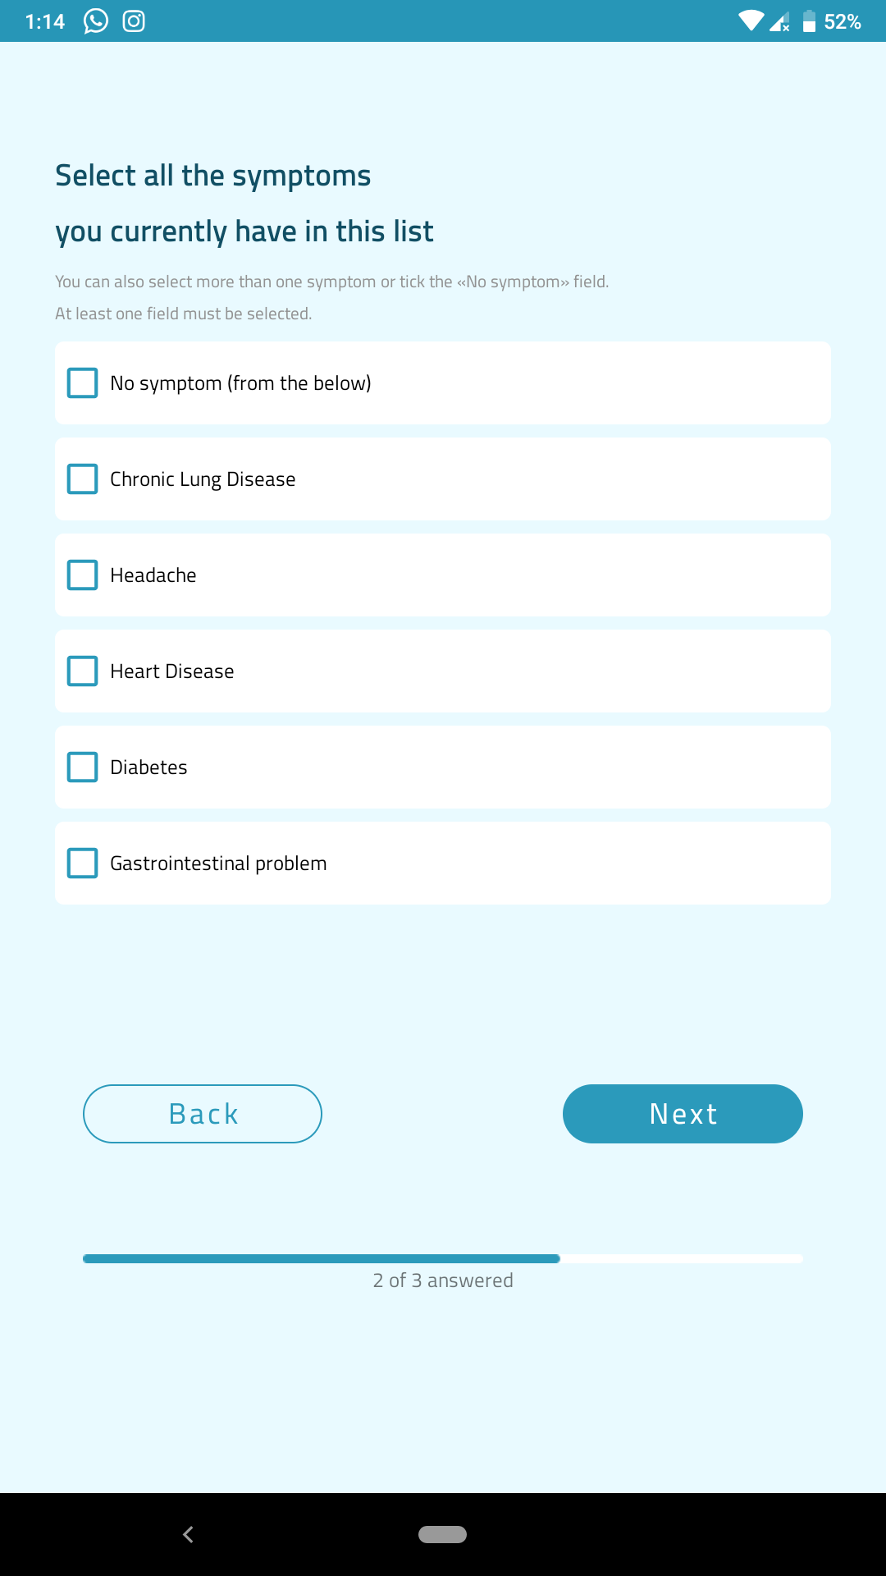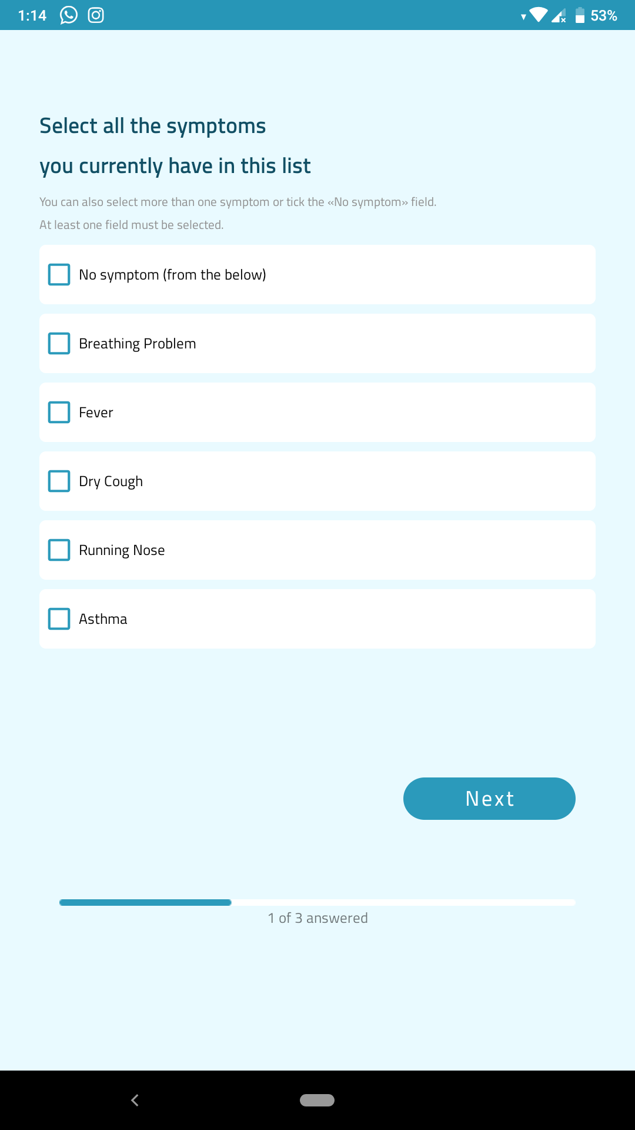

In figure ( ) we can see Questions that the application will ask the user to answering for testing   
is he/she has corona virus or not .

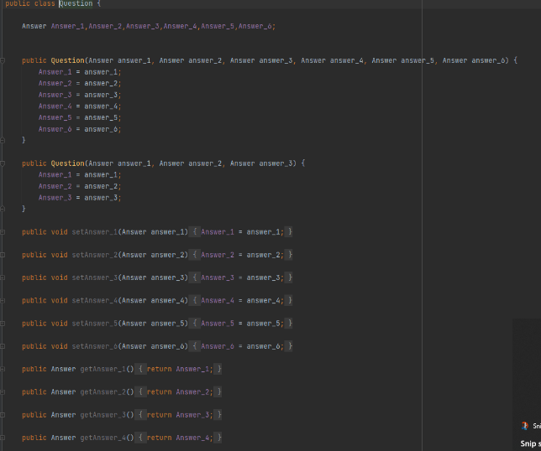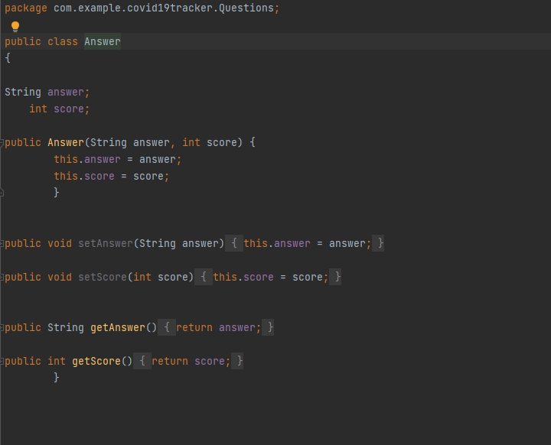

We created two class one to Answers and other to The Qustions.

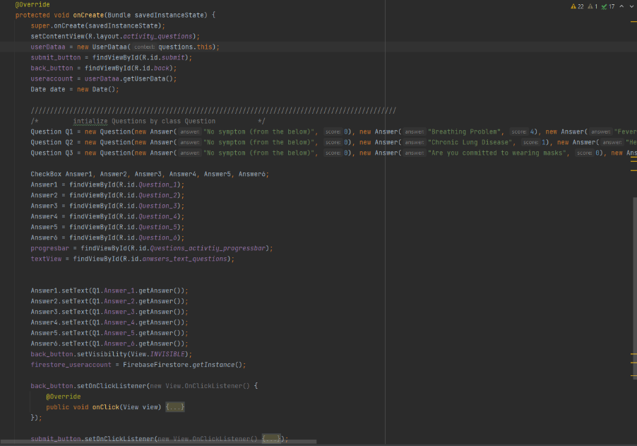

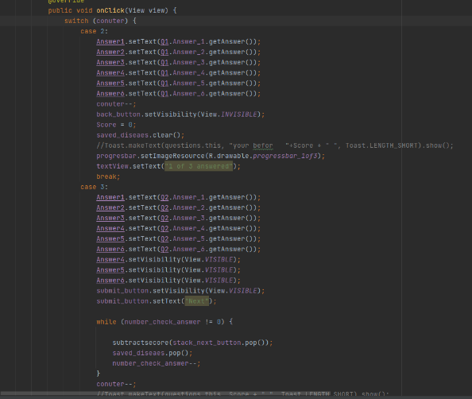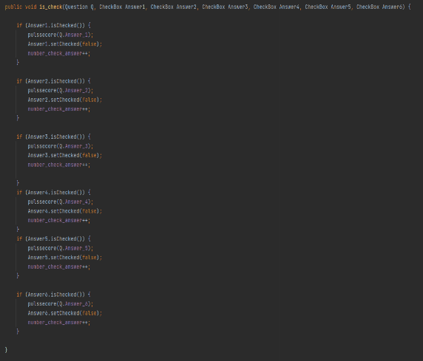

In figure ( ) this implementation of Questions and how we calculate the score to check if

He/she has the corona virus or not .

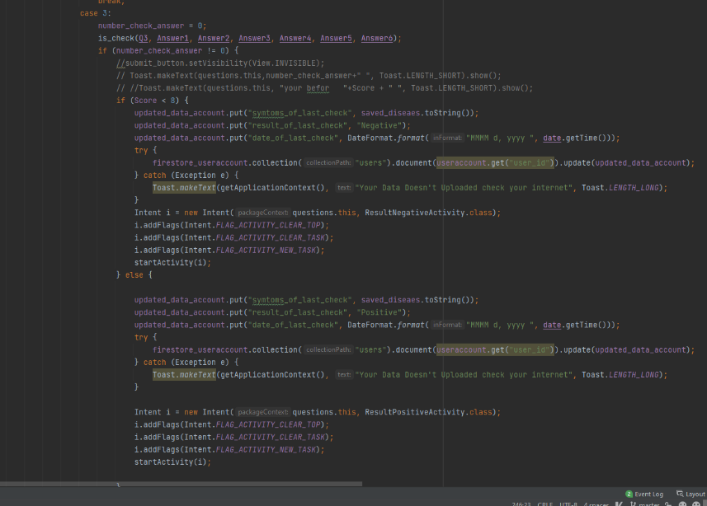

After performing the test and click on  
 result the user will go to the result   
screen to see his/her result.

In figure ( ) the implementation of   
the result button and how answers that   
the user chose it and his/her results   
sent to firebase ,And saved on it.

Result screen

After the user answer the questions we have two ways:

* Positive means that user have the virus
* 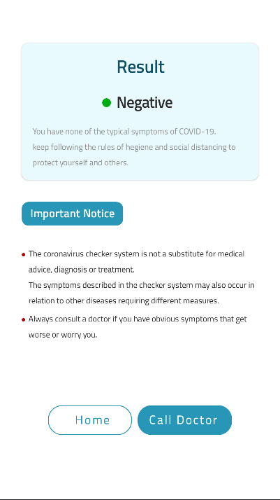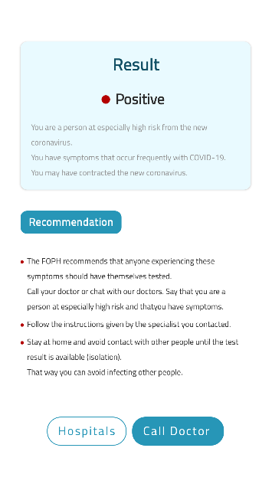 Negative means that user didn’t have the virus.

After check user have to ways:

1. Back to home screen
2. Call the doctor

Call doctor

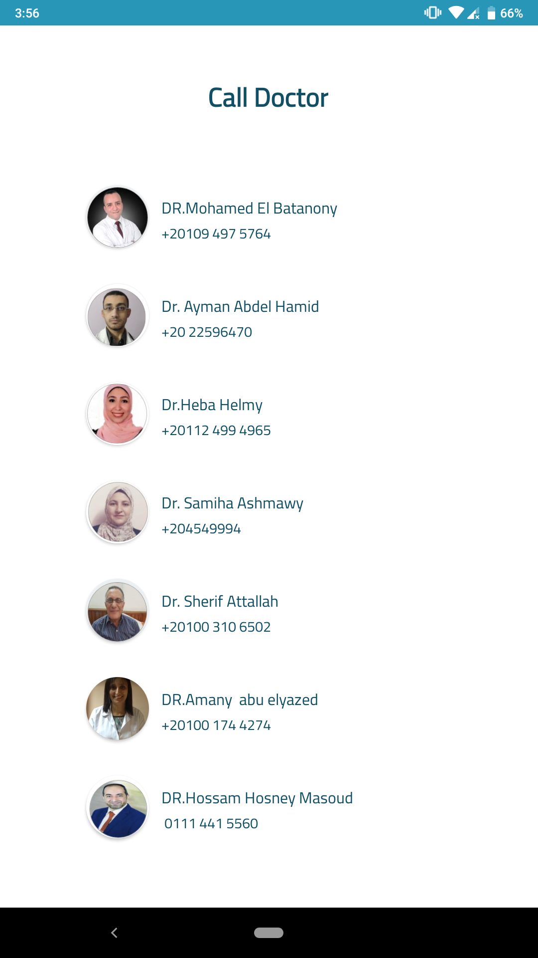

Here we can the design of Call doctor activity in figure ( )

this get the result from fire base and if click of any

doctor’s number , the app will open the phone app and if the

user want to call this doctor now or not

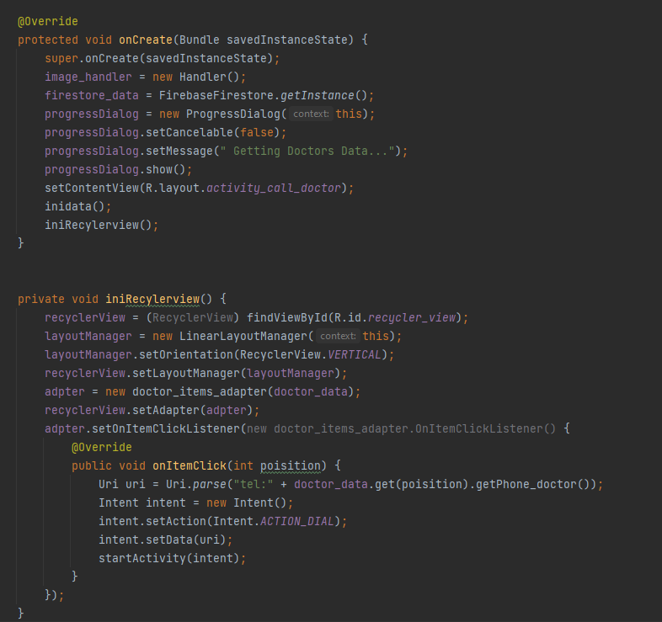

In figure ( ) we can see the implementation of this activity and see how the data of doctor is got from the firebase and displayed in recycler view

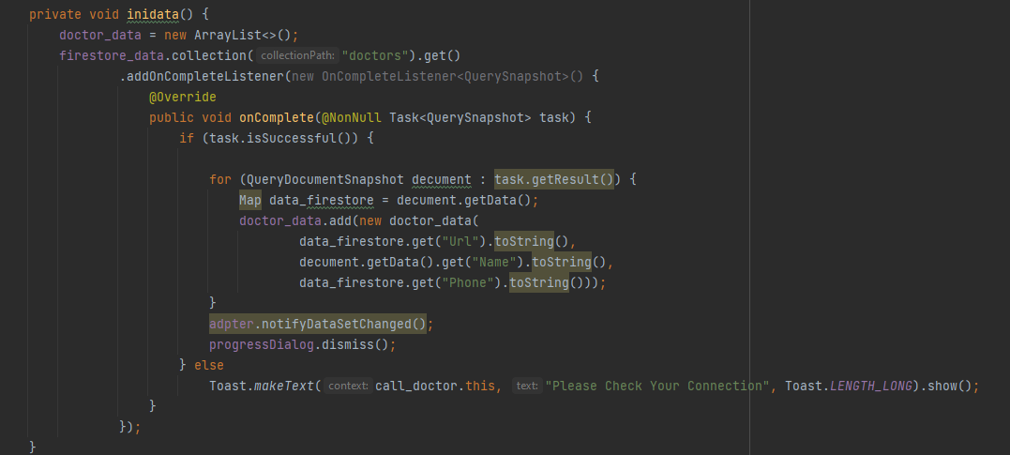

Now we can get data from firebase and initial to recycler view and displayed on call doctor activaty

News screen

Nothing great it’s just a design screen designed by el designer el fager nafe3

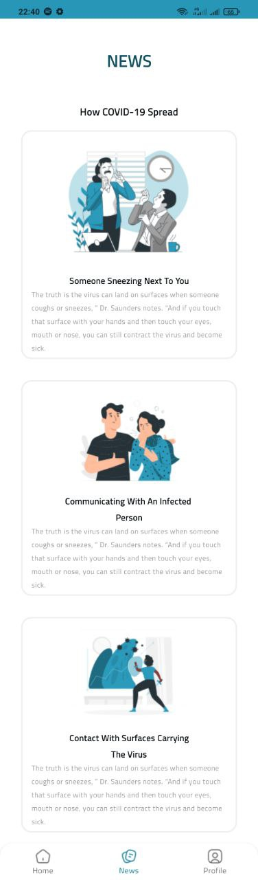

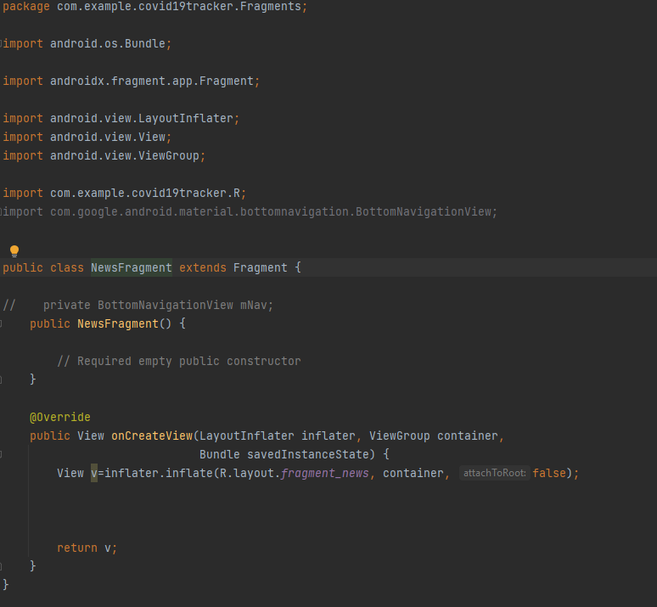

Profile screen

In this screen we show the data that the user entered in sign up screen we grab it from firestore and we grab the result of last check

Screen here

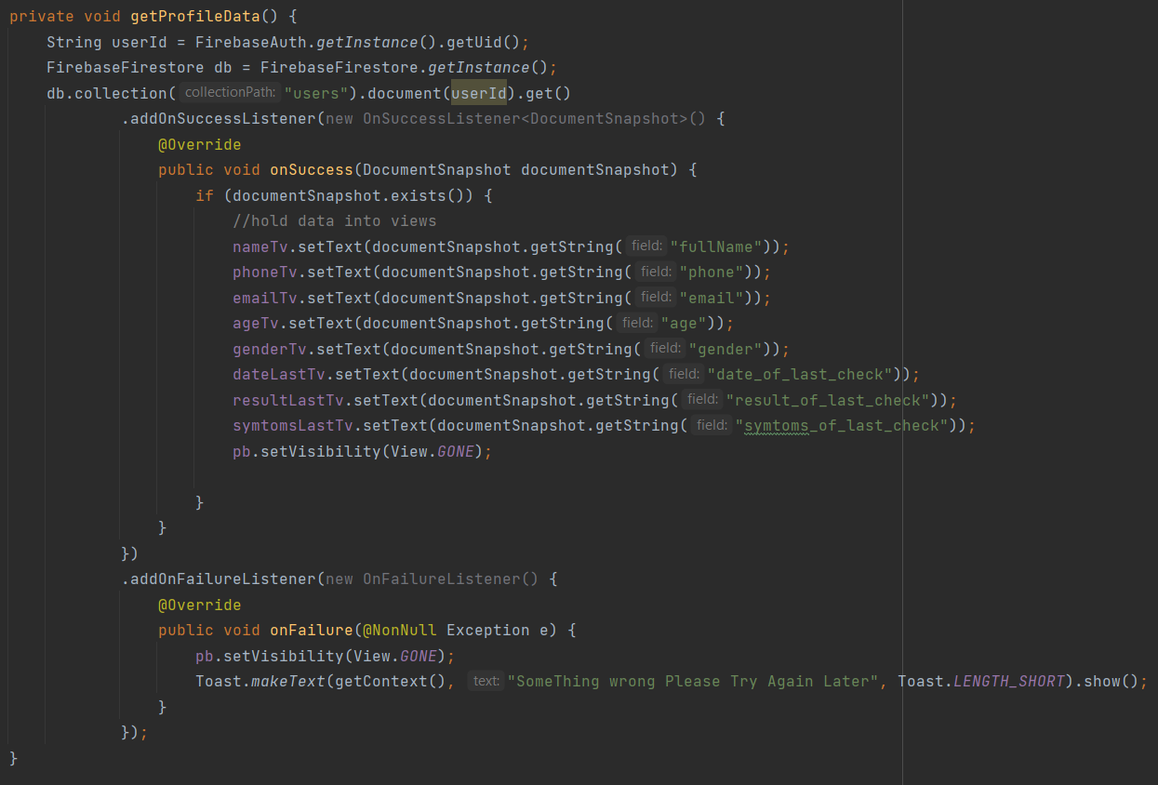After intiating views we use getProfileData() function to get the data and hold it into views

* First we get the user id from firebase and store it
* Then we access the document of the current user and get all data that stored
* And finally we view it in some view
* If were problem the app will show a toast with the error which mostly bad connection

The log out button

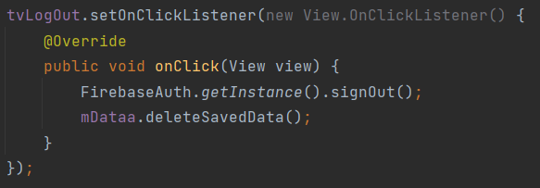It’s a normal button that log out the user from the app and clear all data saved in shared preferences.

We call fire base signout function and deleteSavedData() function that clear all data saved in shared preferences.

# Machine Model

Here we will talk about machine learning model and what were we use in our project .

We used the CNN (convolutional neural network) to classify the masked and no masked faces.

Now what is the CNN ?

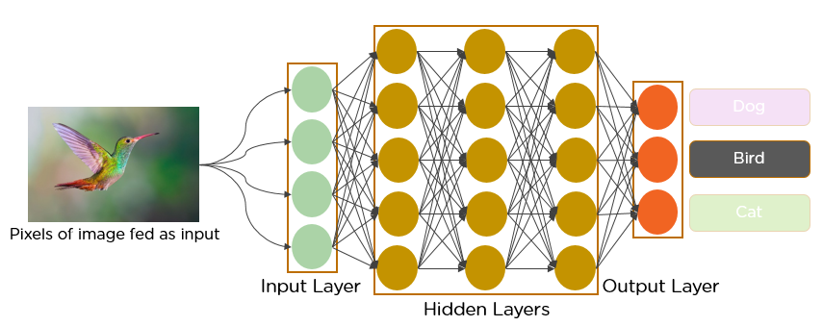Convolutional neural networks are a specialized type of artificial neural networks that use a mathematical operation called convolution in place of general matrix multiplication in at least one of their layers. They are specifically designed to process pixel data and are used in image recognition and processing.

In deep learning, a **convolutional neural network** (**CNN**, or **ConvNet**) is a class of [artificial neural network](https://en.wikipedia.org/wiki/Artificial_neural_network) (**ANN**), most commonly applied to analyze visual imagery.CNNs are also known as **Shift Invariant** or **Space Invariant Artificial Neural Networks** (**SIANN**), based on the shared-weight architecture of the convolution kernels or filters that slide along input features and provide translation-[equivariant](https://en.wikipedia.org/wiki/Equivariant_map" \o "Equivariant map) responses known as feature maps.Counter-intuitively, most convolutional neural networks are only [equivariant](https://en.wikipedia.org/wiki/Equivariant_map), as opposed to invariant, to translation.They have applications in image and video recognition,recommender systems,image classification,image segmentation,medical image analysis,natural language processing,brain–computer interfaces,and financial time series.

Architecture of CNN

A convolutional neural network consists of an input layer, hidden layers and an output layer. In any feed-forward neural network, any middle layers are called hidden because their inputs and outputs are masked by the activation function and final convolution. In a convolutional neural network, the hidden layers include layers that perform convolutions. Typically this includes a layer that performs a dot product of the convolution kernel with the layer's input matrix. This product is usually the Frobenius inner product , and its activation function is commonly ReLU. As the convolution kernel slides along the input matrix for the layer, the convolution operation generates a feature map, which in turn contributes to the input of the next layer. This is followed by other layers such as pooling layers, fully connected layers, and normalization layers.

Now we underused the Architecture of CNN we can dive in what are we done ?

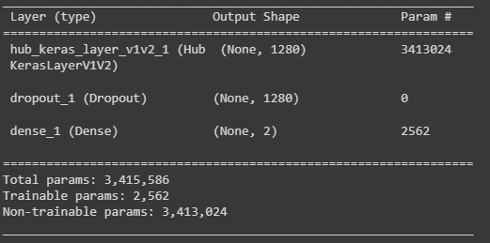

We Have 3415856 node in our CNN and we train our model with our dataset .

Our dataset Consists of two categories (Masked people –No masked people) and has 3850 photo

This screens from our dataset

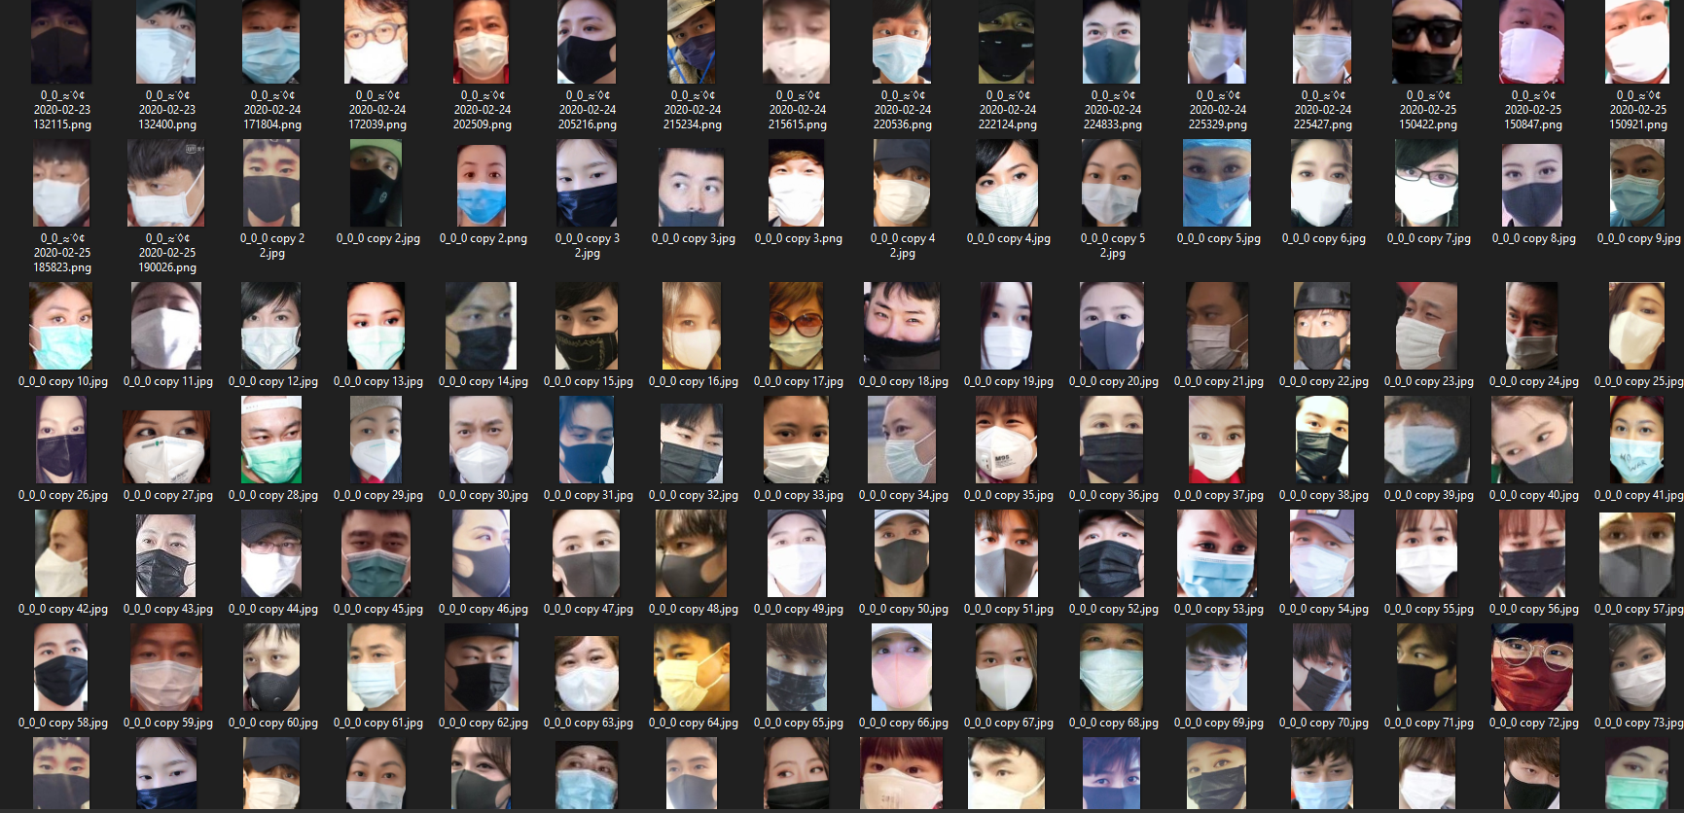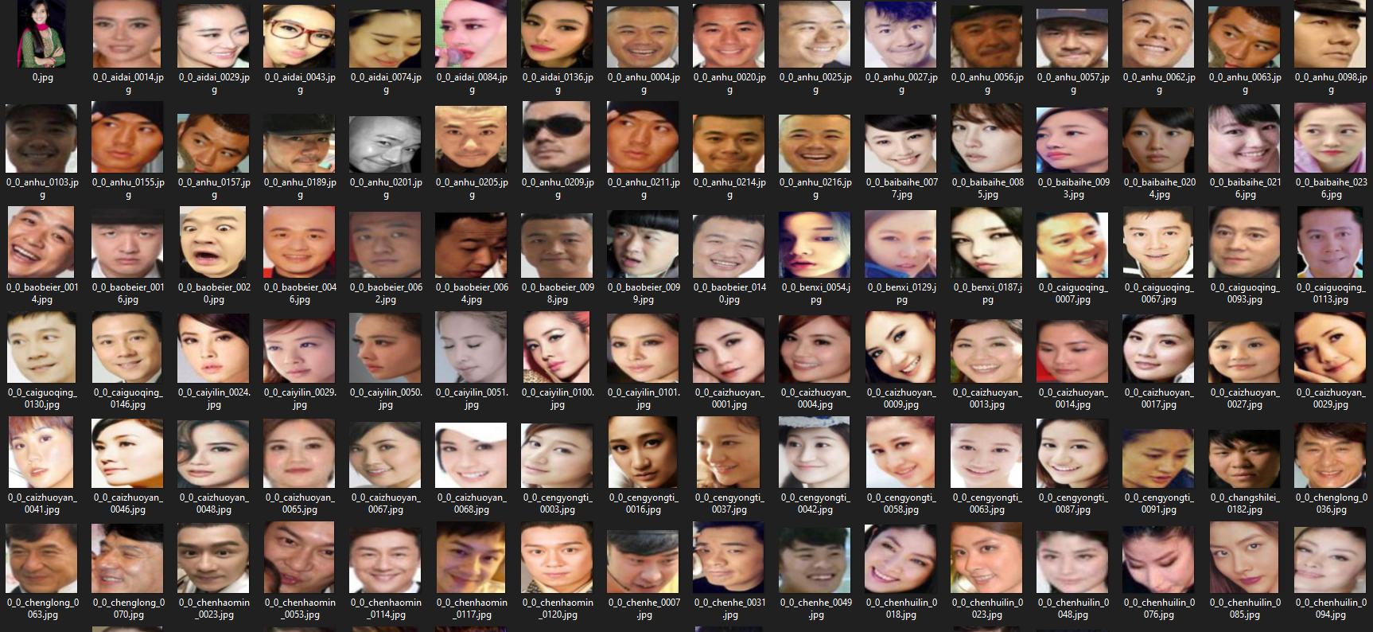

After this model we can get this results and this accuracy

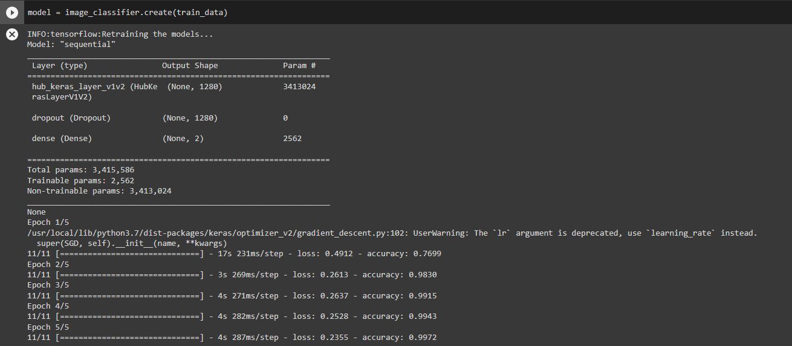

We get the last accuracy 0.9972 on training this model after 5 epoch and each epoch has 11cycle.

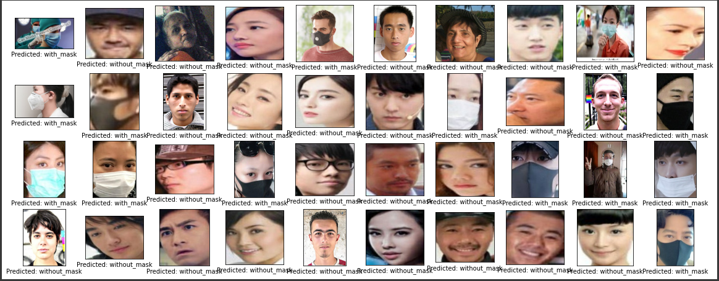

In figure ( ) we can see the test data and the prediction of model on it , we have very good accuracy .

Now should transform this model form tensor flow to tensor flow lite to work in mobile phone  
we can now used this model in our application.